Cheesemaking onsite since 1995.

Book Online:

huntervalleycheese.com.au

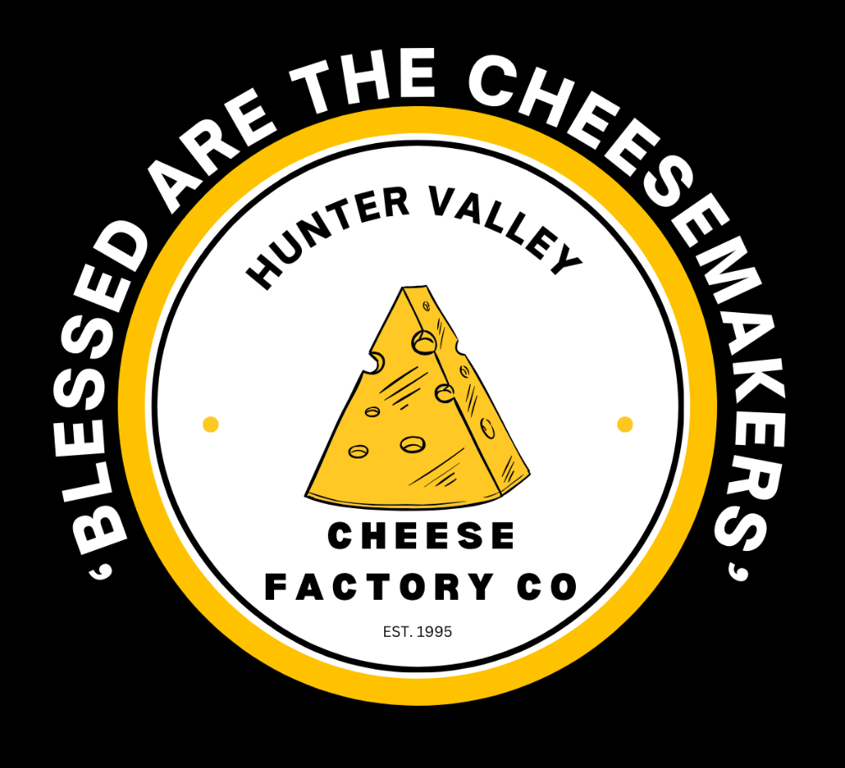

447 McDonald's Rd., Pokolbin 2320

(next to Brokenwood Wines)

[contact@huntervalleycheese.com.au](mailto:contact@huntervalleycheese.com.au)

Direct Contact: Rose (Fromager) 0417 463 759

HUNTER VALLEY CHEESE & LOCAL PRODUCE TASTING $15.50per guest

Seated tasting with table water and souvenir tasting notes.

Five (5) handmade cheeses with matching gourmet crackers.

Olives, oils, jams & chutney w/crackers and bread.

Cheese chat by Cheese Expert with Question & Answer session.

Viewing windows to the cheesemaking & cheese maturation room.

Add 1 wine taste $5. Add 2 wine taste $10 Add Kombucha Taste $5

HUNTER VALLEY CHEESE -- BUILD YOUR OWN CHEESEBOARD $33.00per guest

Seated inside or alfresco with table water.

Four (4) handmade cheeses, choose mild, medium, or strong flavours

House-made Chutney or Fruit Paste

• Quality Breads & Crackers (Gluten Free available)

• The menu allows you to build your cheeseboard with olives, dip, meats, nuts,

$33.00 per guest (4 cheese)

ARTISAN CHEESEMAKERS PAIRING. $52.50per guest

Cheese, Wine & Chocolate with the experts

An unforgettable “maker’s tasting”.

This exclusive experience commences with a warm welcome and a glass of sparkling wine, followed by a guided tasting of four curated pairings. Each course combines the harmony of cheese, wine and chocolate, including strawberries chocolate, exquisite cheese and dessert wine.

Your dedicated pairing expert will host your table to share insights and answer your questions.

Complimentary coffee and sweet treat round off your experience.

Non-Alcoholic Options Available

ARTISAN CHEESE MASTERCLASS & TASTING CLASS $120.00per guest

One on one session, duration 45minutes, schedule your time now !

Eight (8) handmade cheeses matched to gourmet crackers or breads.

Regional & Housemade Olives, oils, jams and chutney tasting

Hosted by a Cheese Expert, discover the world of cheese styles, textures & flavours – ask those cheesy questions keeping you awake at night

How to care for your cheese at home, how to select cheese to create your

cheese platters for entertaining at home

• How we make our cheese overview at our cheese factory viewing windows

One Home Cheesemaking Kit is included in each Masterclass booking (Value $39.99)

Add 1 wine taste $5. Add 2 wine taste $10 Add Kombucha Taste $5

Cont’d….2

Cheesemaking onsite since 1995.

Book Online:

huntervalleycheese.com.au



447 McDonald's Rd., Pokolbin 2320

(next to Brokenwood Wines)

[contact@huntervalleycheese.com.au](mailto:contact@huntervalleycheese.com.au)

Direct Contact: Rose (Fromager) 0417 463 759

CHEESEMAKING DEMO & TASTING SCHOOL \* $35.00per adult $10per child

Unique Fundamentals of Cheesemaking with live interactive demonstration & tasting

Instructional chat through the milk to cheese process

• Hunter Valley Cheese & Local Produce Tasting (value $15.50) – kids cheese board available

How to look after cheese at home and selection at the store.

• Fun Education & Memorable Activity for adults and children alike

Bookings for 6persons or more only - \*2 day advance booking required

Add 1 wine taste $5. Add 2 wine taste $10 Add Kombucha Taste $5

SMALL BATCH CHEESEMAKING WORKSHOP $200.00 per person

Learn how to make cheese from our experienced Cheesemaker !! No better teacher !!

Discover how to make cheese at home 2.5hours of ‘hands on” cheesemaking.

Food Safe Code Workshop

Learn hygiene, equipment, milk choices, enzymes, coagulation and ripening in cheesemaking.

Includes eight (8) cheese with wine matching - Cheese & Wine matching Masterclass

while cheese is ripening (Value $75per person)

Learn how to “whey off,” marinate and care for your cheese at home.

Understand food labelling requirements – name your own cheese!!

Take you cheese home

One Home Cheesemaking Kit is included in each Masterclass booking (Value $39.99)

•

Personalise your Visit:

Groups over 15 guests are invited to call, text or email to curate your tasting, lunch or workshop to suit

your specific interest level -- cheese tasting, lunch or education or recreational.

Sharing our passion and knowledge of cheesemaking hospitality & tourism in Australia for over 30 years

Hunter Valley Cheese Factory

cheesemaking, cheese & food tourism, education & tastings.

Direct Contact: Rose (Fromager) 0417 463 759